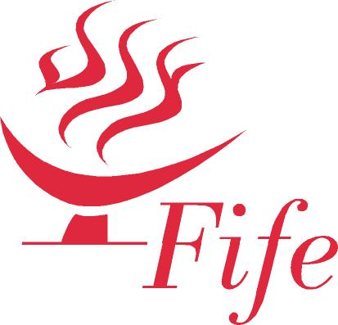

DISABILITY SPORT FIFE

About Us…….

Disability Sport Fife (DSF) was established in 1977. In 2015 DSF celebrated 38 years as the Fife lead body in disability sport for children, athletes and players of all ages and abilities with a physical, sensory or learning disability. DSF is a branch of Scottish Disability Sport (SDS) with a charity registration number of (SC 020994). DSF athlete members have been enormously successful in European and World Championships plus Paralympic Games all over the world. DSF has supported 22 members to become GB Paralympians since 1977. DSF individual members and teams have enjoyed enormous success in national events organised by SDS. Each year DSF organises an extensive programme of sports events and provides education and training opportunities for coaches and volunteers. DSF employs an experienced team of coaches on a session by session basis to deliver sports specific activity sessions weekly across Fife. DSF has a part time administrator based at the Michael Woods Sports and Leisure Centre financially supported by a Fife Council grant. DSF has Service Level Agreements with the Fife Sports and Leisure Trust and works in partnership with Fife Council. DSF has a number of Committees that deal with Finance, Policy, Performance Sport, and Safeguarding in Sport/Equity. DSF has established a Hall of Fame to recognise performance athletes who have achieved significant success in international disability sport. The DSF Annual General Meeting and Awards Evening is now a significant occasion in the Fife Sporting Year with over 80 attendees.

Some of Our Recent Achievements:

- The 2015 DSF calendar has 36 sports events and 30 weekly sports specific or multi sports sessions available to members. DSF supports members to compete in many sport specific annual national events.
- Six DSF Summer and Winter Paralympians were among the first 20 Scots inducted into the Scottish Disability Sport Hall of Fame at the 2012 annual General Meeting.
- Each year DSF members compete in major events throughout the world.
- Fife athletes won the team title at the 2015 SDS National Athletics Championships for the fifth time in six years and Fife bowlers won the 2015 Inter Region national bowls title at Kelvingrove in Glasgow, scene of the very successful 2014 Commonwealth Games.
- DSF produces monthly newsletters and submits press articles on the achievements of members to local press and web sites weekly.
- DSF supports the Fife Futures squad of high performance athletes with Paralympic or Commonwealth Games potential. Kieran Steer (boccia), Martin Hunter, Michael Simpson, Maria Spencer (bowls), Brad Stewart (archery), Derek Rae and Owen Miller (athletics), Craig Rodgie and Kirsty Brunton (swimming), Alison Patrick and Stefan Hoggan (Para-triathlon) are just some of the high performance DSF members who have excelled in Para-sport in 2015.

In the development of specific sports, DSF has been supported for almost a decade by the Big Lottery. The DSF NOPES IMAGE Project funded the development of around 30 weekly sports options across Fife for children and young people with a disability. The BL Active Futures DSF VORTEX project was launched in late 2007 in partnership with Fife Colleges and others, creating in excess of 20 weekly sports opportunities for 17-24 year olds with a disability across Fife. In 2012 DSF was awarded a 10K grant by Awards for All to develop coach led sessions across Fife under the banner of Parallel Sport. The Project was successfully concluded early in 2013 with enhanced provision in the sports of athletics, tennis, swimming, multi sports and junior sport in particular. In 2014 the Big Lottery supported DSF with an inclusive badminton initiative that increased participation and accessed appropriate equipment and coach education.

DSF athlete members and coaches have represented GB at every Paralympic Games since 1984. DSF has established a Fife Hall of Fame to celebrate the achievements of great GB Summer and Winter Paralympians from Fife.

In the late 70s DSF became involved with the Special Olympics movement. In 1982 a Scottish Special Olympics Team participated in the first GB Special Olympic Games in Liverpool through SDS and the DSF President was the Team Manager. DSF members played a significant part in the performance of Team Scotland, winner of the Games Team Trophy. This was the first, and last occasion, that Special Olympians from north of the Border competed under the banner of Scotland at a GB Games. After 1982 teams competed as individual Scottish area members of SOGB and Fife Special Olympians have been part of Games in locations as far afield as the Isle of Man, Brighton, Portsmouth, Sheffield, Leicester, Glasgow, Cardiff, Dublin, Athens, Shanghai and various cities in the USA. DSF has been directly responsible for funding, selecting and preparing Fife teams for successive Games at home and overseas. Fife supported over 200 athletes and players plus coaches to attend each of the GB Summer Special Olympic Games in Glasgow in 2005 and Leicester in 2009. This has been possible because of the enormous financial support that was forthcoming from communities and community organisations across Fife. In excess of 70K was raised for the Games in Leicester through hugely successful fund raising ventures coordinated by DSF.

- DSF operates across Fife with a history of supporting individuals of all ages and abilities with a physical, sensory or learning disability.
- DSF is a multi sport organisation with strong local, national and international connections.
- DSF has many partners including Fife Council, the Fife Sports and Leisure Trust, Scottish Disability Sport, Active Fife and sportscotland.
- DSF has key funding partners whose support has been critical to DSF success. In particular the Big Lottery, Order of St John in Fife, Rotary International (Fife clubs), UNISON Fife branch, Margaret Pullar (Bill Pullar Bursary), St Andrews University Saints, the Scottish FA, Soroptimists International (Dunfermline club) and the Royal and Ancient Golf Club etc.
- DSF has strong links with Fife schools and the Active schools Network. Since its inception DSF has worked closely with Social Work Services and many Fife Sports Clubs.
- DSF has a General Management Committee and committee structure covering Finance and Policy, Performance Sport, Safeguarding in Sport/Equity. DSF is proud of the number of athlete members involved in running the Association.
- DSF has a very skilled and dedicated administrator supported through a grant from Fife Council Housing and Communities.

Our Team

Richard Brickley MBE President, Paul Noble MBE Chairman, David Thomson Secretary and Norma Buchanan Administrator. DSF has very strong links with Active Fife and Active Schools and Maureen McSeveney (Social work Services) and Anna Tizzard (Active Fife) are key players. DSF has a dedicated team of volunteers and coaches who work tirelessly on behalf of our members year after year.

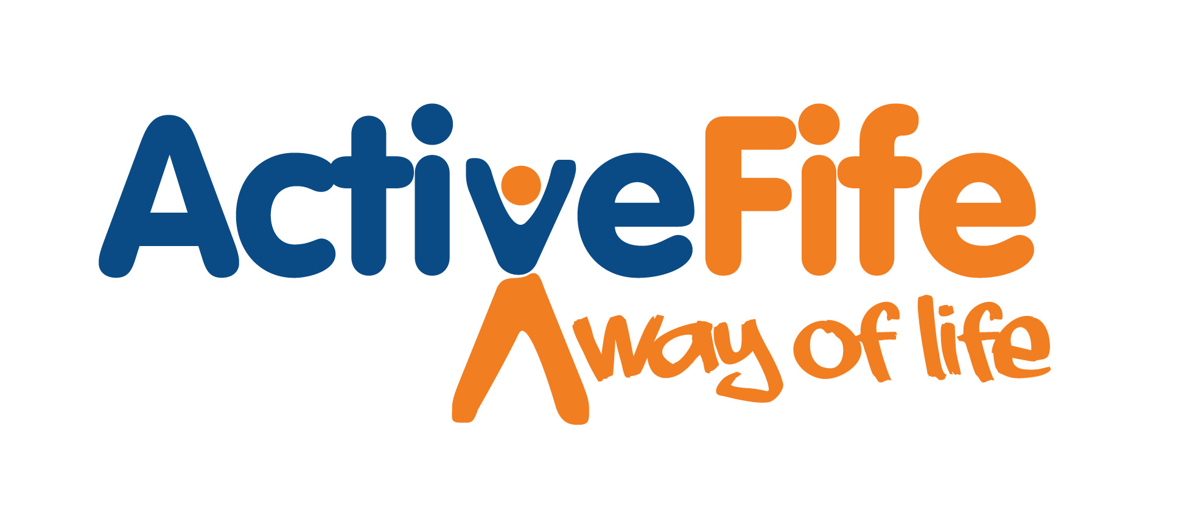

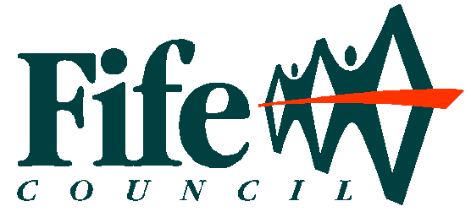
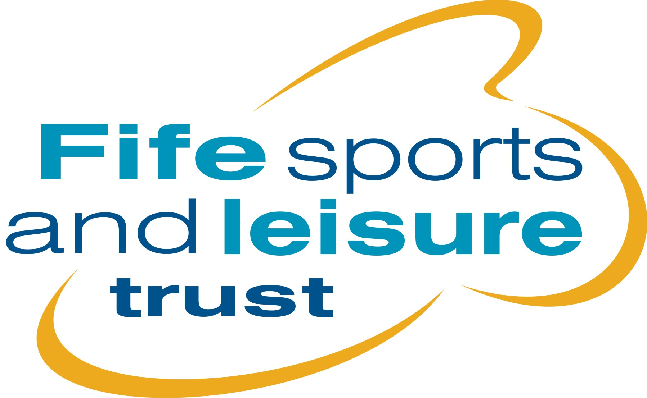
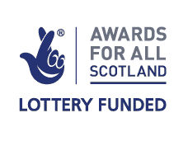



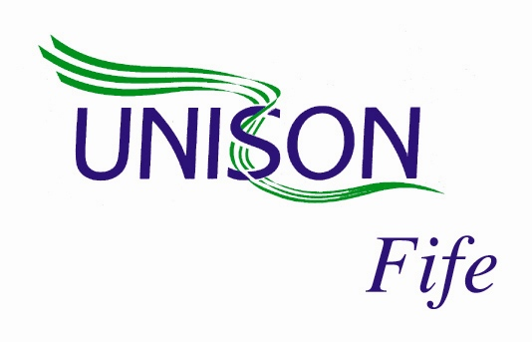


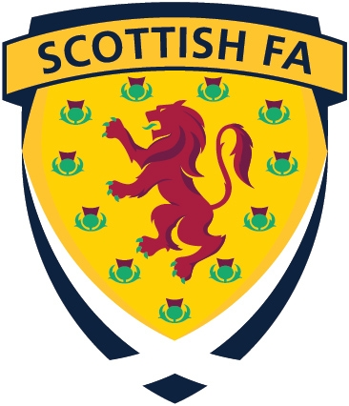

Courier
Fife Free Press Group

Document prepared by Richard Brickley, MBE, President, Disability Sport Fife.

For further information contact:

Norma Buchanan | Administrator  Disability Sport Fife  Michael Woods Sports & Leisure Centre  Viewfield  Glenrothes  Fife KY6 2RD
Tel 03451 55 55 55 plus Ext 444989
Email norma.buchanan@fife.gov.uk

