Please register & vote to support this project & ask your friends & family to do the same. You could win £100. Thank you

Take a few minutes to go to this website then register & vote:

https://foundation.onefamily.com/projects/wellwood-fencing-facility-community-centre/

Wellwood Fencing Facility & Community Centre
Conversion of a former primary school into multi-functional building providing a facility that can be used by West Fife Fencing Club (WFFC) & Scottish Fencing (SF)& for other purposes by a wide variety of groups & individuals from the local community. Beneficiaries: WFFC & SF members, all residents of wider Dunfermline & West Fife community.
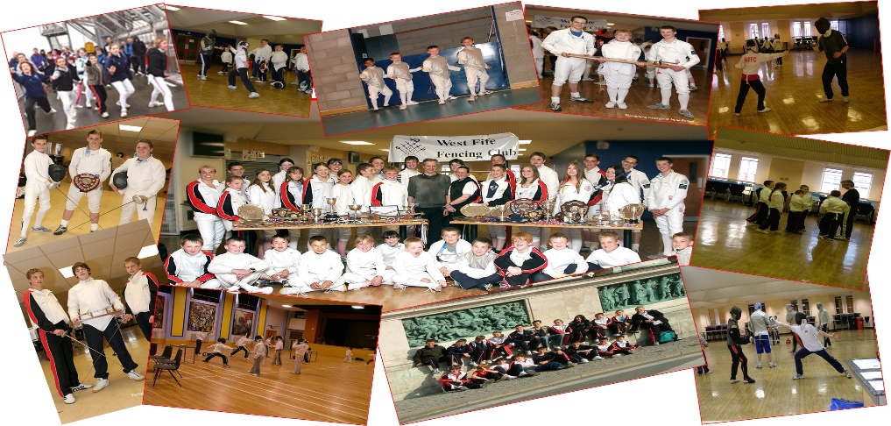

Project objectives
- To provide a permanent home for West Fife Fencing Club (SCIO charity no. SC045885) whose aim is to make the Olympic sport of fencing available & affordable for all people in the Dunfermline & West Fife area.
- To provide the local community of Wellwood & North Dunfermline with a multi-use community centre that can meet the needs of a wide variety of groups & individuals.
- To provide a facility that can be used by the wider fencing community in Scotland for training fencers, coaches & officials thereby increasing the availability of fencing throughout Scotland.

How could your project be achieved using a Community Award?
The primary school property has already been purchased by WFFC. The Community Award will fund the conversion of the property into a multi-purpose property by paying for removal of internal walls, laying of multi-use flooring, equipping meeting rooms, kitchen, changing rooms & storage areas.

How would this money make a difference to your community?
WFFC is a successful fencing club but has achieved its success from a school dining hall & assembly hall. With a permanent home WFFC could make fencing more widely available to many more people. The local community would benefit from a facility well equipped for a variety of activities: meetings, sports/fitness, hobbies, children’s parties etc

